ECE 3355 – ELECTRONICS
HOMEWORK #10

Sedra and Smith 8th Ed. Chapter 7: Problems 7.125, 7.131
Extra Problems E10.1, E10.2, E10.3

10.1 The circuit shown below is a common-base amplifier. Assume β = 100, and room temperature operation. Note that the input is at the emitter, and the output is at the collector.
a) Confirm that the transistor is biased in the active region.
b) Draw the ac small-signal equivalent circuit.
c) Find the signal voltage gain, v_{o}/v_{s}, in the passband.
d) Find the signal current gain, i_{o}/i_{s}, in the passband.

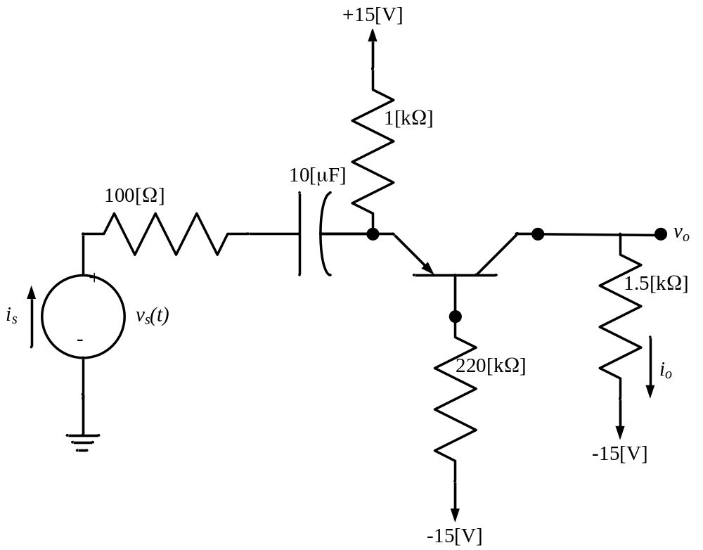

10.2 The circuit shown below is a common-collector amplifier, also known as an emitter-follower. Assume β = 100, and room temperature operation. Note that the input is at the base, and the output is at the emitter.
a) Find the voltage gain, v_{o}/v_{s}, and the current gain, i_{o}/i_{s}, in the pass band.
b) Find the input resistance R_{i} in the passband.
c) Find the output resistance R_{o} in the passband.

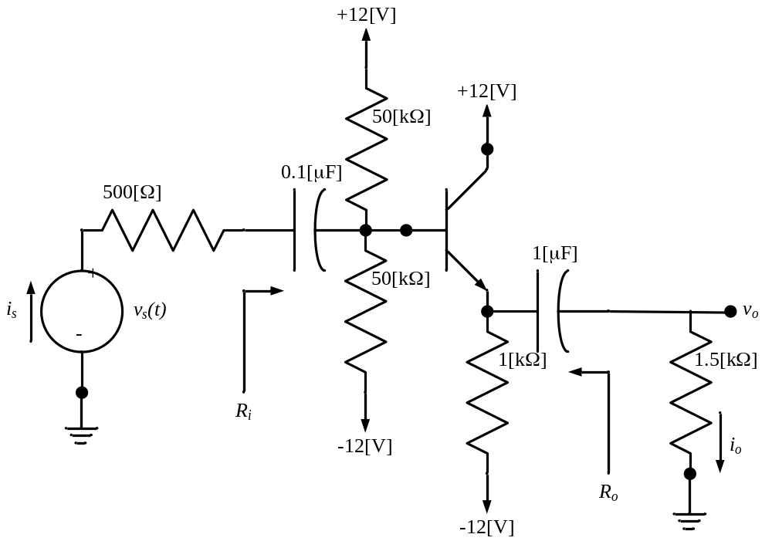

10.3 The circuit shown below is a common-emitter amplifier. Assume β = 100, and room temperature operation. Note that the input is at the base, and the output is at the collector.
a) Find the signal voltage gain, v_{o}/v_{s}, in the passband.
b) Find the signal current gain, i_{o}/i_{s}, in the passband.

